Create a react app for Student Management Portal named scorecalculatorapp and create a function component named “CalculateScore” which will accept Name, School, Total and goal in order to calculate the average score of a student and display the same.

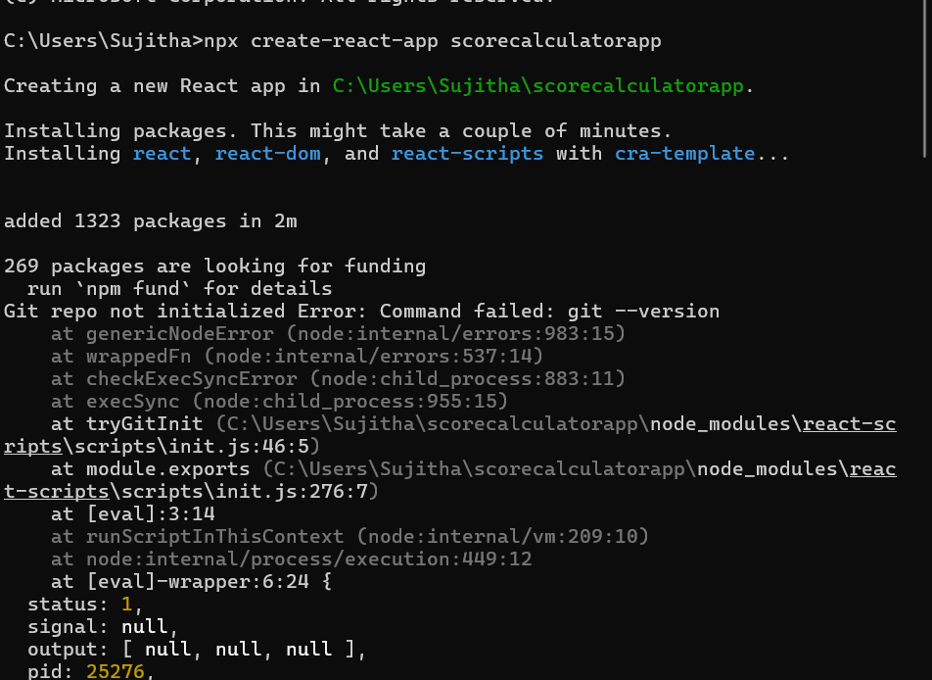

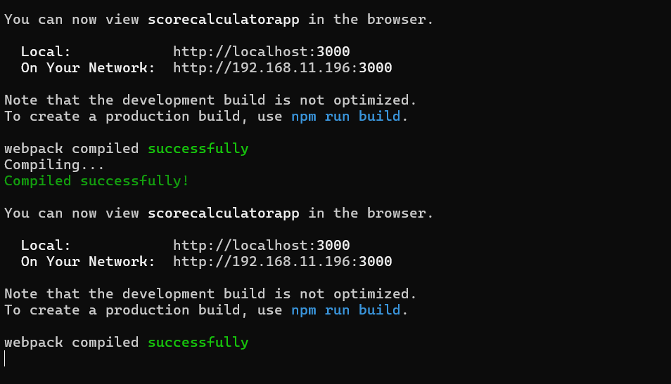

CalculateScore.js

import React from "react";

import '../Stylesheets/mystyle.css';

function CalculateScore(props){

 const average = props.total / props.goal;

 return(

   <div className="score-card">

   <h2>Student Score Details</h2>

   <p><strong>Name:</strong>{props.name}</p>

   <p><strong>School:</strong>{props.school}</p>

   <p><strong>Total Marks:</strong>{props.total}</p>

   <p><strong>Goal:</strong>{props.goal}</p>

   <p><strong>Average Score:</strong>{average}</p>

   </div>

 );

}

export default CalculateScore;

mystyle.css

import React from "react";

import '../Stylesheets/mystyle.css';

function CalculateScore(props){

 const average = props.total / props.goal;

 return(

   <div className="score-card">

   <h2>Student Score Details</h2>

   <p><strong>Name:</strong>{props.name}</p>

   <p><strong>School:</strong>{props.school}</p>

   <p><strong>Total Marks:</strong>{props.total}</p>

   <p><strong>Goal:</strong>{props.goal}</p>

   <p><strong>Average Score:</strong>{average}</p>

   </div>

 );

}

export default CalculateScore;

App.js

import React from 'react';

import './App.css';

import CalculateScore from './Components/CalculateScore';

function App() {

 return (

   <div className="App">

   <CalculateScore name="Suji" school="DPS" total={450} goal={5}/>

   </div>

 );

}

export default App;

Output

